CS 255 System Design Document Andre Miranda

This template lays out all the different sections that you need to complete for Project Two. Each section has guidance to prompt your thinking. You will need to continually reference the interview transcript as you work to make sure that you are addressing your client’s needs. There is no required length for the final document. Instead the goal is to complete each section based on what your client’s needs are. Remove this note when you are finished, and replace all bracketed text with the relevant information.

UML Diagrams

UML Use Case Diagram
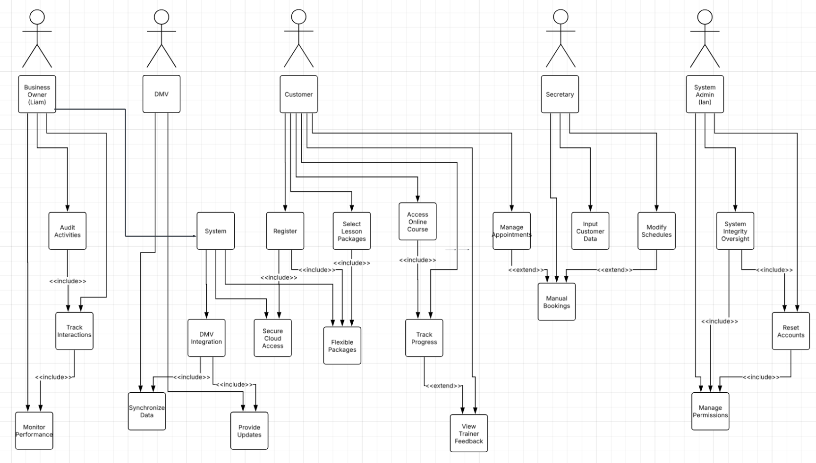

UML Activity Diagrams
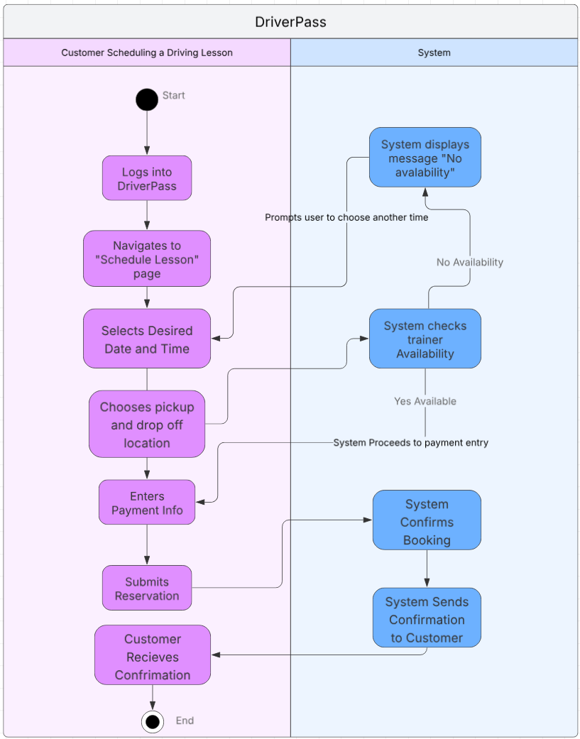

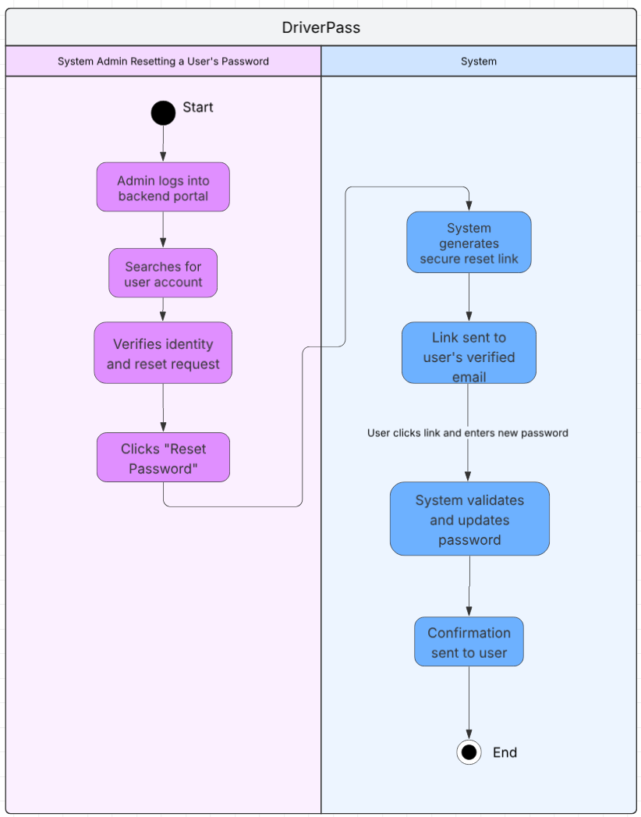

UML Sequence Diagram
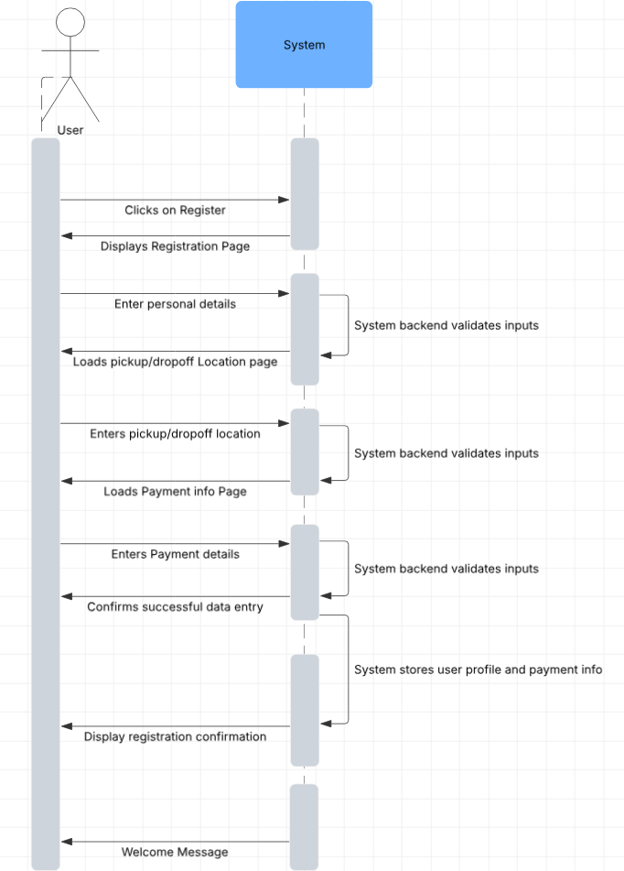

UML Class Diagram
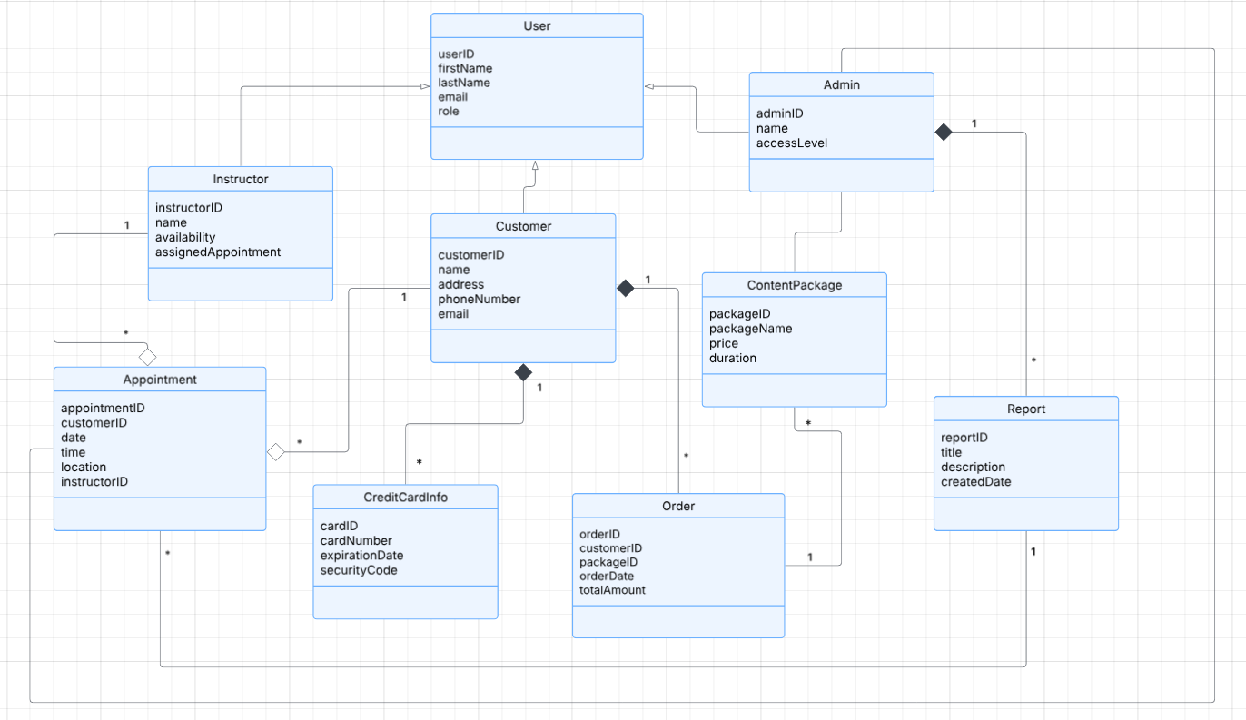

Technical Requirements
Hardware Requirements:
- Surge protectors for power stability
- Desktop computers with sufficient memory and storage for stationary access
- Monitors, keyboards, and mice for staff workstations
- Laptops and mobile phones with adequate storage for remote access
- Ethernet cables and wireless routers for reliable connectivity

Software Requirements:
- DriverPass application for desktop and mobile platforms
- Web browser support for cloud-based access
- Anti-virus software for endpoint security
- Server-based applications for administrative control
- Programming and cloud development software for ongoing updates

Tools Requirements:
- Home or office server setup with development tools
- Consistent high-speed internet for server uploads and real-time updates
- Network monitoring tools for system health and alert tracking

Infrastructure Requirements:
- Reliable building power and internet sources
- Parking lot for trainers, staff, and students
- Designated driving area for in-car training sessions
- Trademark and licensing for DriverPass brand and application
- Secure credit card processing system
- Physical or cloud-based server/mainframe for data storage and operations

System Design Requirements:
- Cloud-hosted platform for fast updates and remote access
- Mobile-friendly interface for on-the-go data access by the owner
- Scalable database to store login credentials, reservations, and progress tracking
- SSL encryption for all data transfers, both external and internal
- Role-based access control to differentiate permissions for owner, IT officer, secretary, and customers

